ADYPU Mid 1

UNIT TEST - 1

Section - I (2 x 5 Marks = 10 Marks)
Answer any two of the following questions

- a)
Convert decimal 345 into octal.
A) 521
B) 536
C) 541
D) 531
Convert (B3)₁₆ into binary.
A) 10110011
B) 10111001
C) 10110101
D) 10111100
Express −45 in 8-bit 2’s complement form.
A) 11010010
B) 11010011
C) 11010101
D) 11001101

Two integers are given A = (11011010)₂ , B = (10101100)₂ A system computes:
R = (A XOR B) AND ((A OR B) << 1)
What is the value of R in binary (8-bit result)?
a) 01010000
b) 01111000
c) 01110100
d) 10010000

Evaluate: ((11100)₂ + (1011)₂) & ((11111)₂ >> 2)
a) 101010
b) 111011
c) 110000
d) 000111

- b) State and explain different approaches to evaluate the 2’s complement of a number with examples.

- c) Convert the binary number (1101.101)₂ to its equivalent decimal and hexadecimal forms, showing all steps.

Section - II (2 x 5 Marks = 10 Marks)
Answer any two of the following questions
- a) The data bits are 101100, and the generator polynomial is
𝐺(𝑥) = 𝑥³+1. Perform the CRC calculation and find the transmitted data.
2. b) Find the Multiplicative Inverse of 9 modulo 13 using the Extended Euclidean Algorithm.

2. c) If the LCM of two numbers is 495 and their GCD is 5, and the sum of the two numbers is 100, find the numbers.

ADYPU Mid 1 Answers

Unit Test 1 Solutions

- a)
Convert decimal 345 into octal. (1 Mark)
A) 521
B) 536
C) 541
D) 531
Answer:
D) 531
b) Convert (B3)₁₆ into binary. (1 Mark)
A) 10110011
B) 10111001
C) 10110101
D) 10111100
Answer:
A) 10110011
c) Express −45 in 8-bit 2’s complement form. (1 Mark)
A) 11010010
B) 11010011
C) 11010101
D) 11001101
Answer:
B) 11010011
d) Two integers are given A = (11011010)₂ , B = (10101100)₂ A system computes:
R = (A XOR B) AND ((A OR B) << 1)
What is the value of R in binary (8-bit result)? (1 Mark)
a) 01010000
b) 01111000
c) 01110100
d) 10010000
Answer: c) 01110100
e) Evaluate: ((11100)₂ + (1011)₂) & ((11111)₂ >> 2) (1 Mark)
a) 101010
b) 111011
c) 110000
d) 000111
Answer: d)000111
- State and explain different approaches to evaluate the 2’s complement of a number with examples.
Ans:
There are three methods to find the 2’s complement of a number:
- Evaluate the 1’s complement and add one
- Inversion after the first
- Mathematical Formula
(0.5 Marks till here)
- Evaluate the 1’s complement and add one: (1.5 Marks)
- Write the binary representation of the positive version of the number in binary format.
- Find the One's Complement.
- Add 1 to the One's Complement result.
- The result is the Two's Complement representation of the negative number.
Example: - 20
+20 is represented by 00010100
1’s complement = 11101011
Adding 1 to 1’s complement = 11101011 + 00000001 = 11101100

- Inversion after first: (1.5 Marks)
- Write the binary form of the positive number using the required number of bits (e.g., 8 bits).
- From the rightmost bit (LSB), retain all bits up to and including the first 1 encountered.
- Invert all the bits after the first 1, moving towards the MSB.
- The result is the Two's Complement representation of the negative number.
Example: - 20
+20 is represented by 00010100
00010 (needs to be inverted) | 100 (remains the same)
11101 | 100
= 11101100
- Mathematical Formula: (1.5 Marks)
- Calculate 2ⁿ-N, where n is the number of bits and N is the positive number.
- Convert the result into binary form to get the Two's Complement representation of the negative number.
Example:
n = 8
N = 20
=> 2⁸ - 20 = 256 - 20 = 236
The binary representation of 236 = 11101100

- Convert the binary number (1101.101)₂ to its equivalent decimal and hexadecimal forms, showing all steps.
Ans:
Step 1: Convert the given binary to decimal (2.5 Marks)
Integer part: (1101)₂
(1101)₂ = 1 x 2³ + 1 x 2² + 0 x 2¹ + 1 x 2⁰ = 8 + 4 + 1 = 13

Fractional part: (0.101)₂
(0.101)₂ = 1 x 2⁻¹ + 0 x 2⁻² + 1 x 2⁻ ³ = ½ + ⅛ = 0.625
Therefore,
(1101.101)₂ = (13.625)₁₀
Step 2: (2.5 Marks)
We know that for converting the decimal to hexadecimal, we can group 4 bits
=> (1101. 1010)₂ (here adding a 0 post the decimal towards the right doesn’t change the value)
=> we know that (1101)₂ = (13)₁₀ → (D)₁₆
And (1010)₂ = (10)₁₀ → (A)₁₆
Therefore (1101.1010)₂ = (D. A)₁₆

- a) The data bits are 101100, and the generator polynomial is
𝐺(𝑥) = 𝑥³+1. Perform the CRC calculation and find the transmitted data.
Ans:
Marking Scheme:
- writing the dividend, divisor correctly from the data bits and generator polynomial (1 Mark)
- Each step in the division process (0.5 marks) total correct division process (3 Marks)
- Finding the right CRC and correct transmitted data (1 Mark)
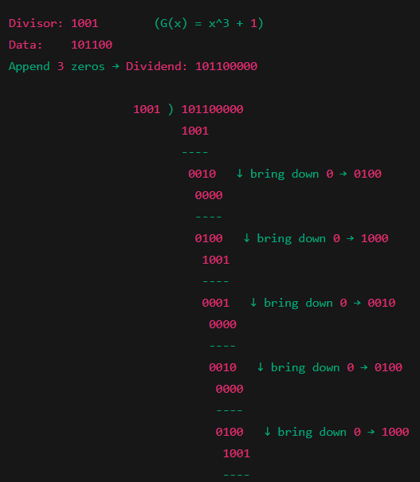
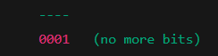

Therefore, CRC = 001

The transmitted data is: 101100001

- Find the Multiplicative Inverse of 9 modulo 13 using the Extended Euclidean Algorithm.
Ans:
Step 1: Check if a Multiplicative Inverse exists (1 Mark)
Here, the multiplicative inverse exists only when GCD(9, 13) = 1 and we know that GCD(9,13) = 1. Therefore, a Multiplicative Inverse exists.
Step 2: Perform division and track the remainders (1 Marks)
13 = 9 x 1 + 4 – (1)
9 = 4 x 1 + 5 – (2)
5 = 4 x 1 + 1 – (3)
4 = 1 x 4 + 0 – (4)
Step 3: working our way up from the bottom of the Euclidean steps
(2 Marks)
From eq (1) we have
1 = 5 - (4 x 1)
From equation (2) we have (9 - 4 x 1) = 5 substitute in the above equation
1 = (9 - 4 x 1) - (4 x 1)
From equation (1) we have 13 - 9 x 1 = 4 substitute in the above equation

1 = (9 - (13 - 9)) - (13 - 9)
1 = 9 - 13 + 9 - 13 + 9
1 = (3 x 9) + (-2)(13)
1 = 9 (3) + 13 (-2)
Step 4: Finding the value of x (the multiplicative inverse) (1 Mark)
This is of the form ax + by = 1 where we are interested in finding the value of x such that we can evaluate (a/b) mod m
Therefore, the value of x = 3
Therefore, 3 is the multiplicative inverse of 9 modulo 13

- If the LCM of two numbers is 495 and their GCD is 5, and the sum of the two numbers is 100, find the numbers.
Ans:
(1 Mark)
Given,
LCM = 495 and GCD = 5
The sum of two numbers is 100
Let,
The two numbers be x and y
=> LCM (x,y) = 495 and GCD (x,y) = 5
We know that GCD (x,y) x LCM (x,y) = xy
=> xy = 495 x 5
=> xy = 2475 – (1)
Since, the sum of two numbers is 100
=> x + y = 100 – (2)
(1 Mark)
=> y = 100 - x
Substitute y = 100 - x in eq (1)
X (100 - x) = 2475
100x - x² = 2475
=> x² - 100x + 2475 = 0
(2 Marks)
By splitting the middle term, we can write
x² - 45x - 55x + 2475 = 0
By taking common terms,
x(x - 45) - 55(x - 45) = 0
(x- 45)(x - 55) = 0
Therefore x = 45 (or) x = 55
(1 Mark)
If x = 45, then from eq (1) we get y = 55
If x = 55, then from eq (1) we get y = 45
Therefore, the two numbers are 45 and 55.

